

Windows Workflow Foundation

Hands-On Lab

Lab ReadMe and Setup Guide
Windows Workflow Foundation
Information in this document, including URL and other Internet Web site references, is subject to change without notice. This document supports a preliminary release of software that may be changed substantially prior to final commercial release, and is the proprietary information of Microsoft Corporation.

This document is for informational purposes only. MICROSOFT MAKES NO WARRANTIES, EITHER EXPRESS OR IMPLIED, AS TO THE INFORMATION IN THIS DOCUMENT.

The entire risk of the use or the results from the use of this document remains with the user. Complying with all applicable copyright laws is the responsibility of the user. Without limiting the rights under copyright, no part of this document may be reproduced, stored in or introduced into a retrieval system, or transmitted in any form or by any means (electronic, mechanical, photocopying, recording, or otherwise), or for any purpose, without the express written permission of Microsoft Corporation.

Microsoft may have patents, patent applications, trademarks, copyrights, or other intellectual property rights covering subject matter in this document. Except as expressly provided in any written license agreement from Microsoft, the furnishing of this document does not give you any license to these patents, trademarks, copyrights, or other intellectual property.

Unless otherwise noted, the example companies, organizations, products, domain names, e-mail addresses, logos, people, places and events depicted herein are fictitious, and no association with any real company, organization, product, domain name, email address, logo, person, place or event is intended or should be inferred.

© 2007 Microsoft Corporation. All rights reserved.

Microsoft, MS-DOS, Windows, Windows NT, Windows Server, Visual C# and Visual Studio are either registered trademarks or trademarks of Microsoft Corporation in the United States and/or other countries.

The names of actual companies and products mentioned herein may be the trademarks of their respective owners.

Description of the 10 Windows Workflow Foundation Labs
WF01 Getting Started with Windows Workflow Foundation
This is an introductory lab to developing workflows in Windows Workflow Foundation. It is based on Visual Studio 2005 with Windows Workflow Foundation and you are guided through a developer experience using Windows Workflow Foundation for the first time. In this lab you will learn creating and debugging a hello world workflow, receive data into the workflow using parameters, and create an expense reporting workflow using IF/Else, declarative conditions and custom activities.

WF02 Creating Custom Activities with Windows Workflow Foundation
Activities are the primary unit of execution, re-use and composition in a workflow. Create simple activities using the activity designer and add it to a workflow in the workflow designer. Exercises include creating an activity with the designer and with code, adding properties to an activity, creating a custom validator, and creating a custom activity design image. As a pre-requisite to this lab you should have completed the Getting Started with Windows Workflow Foundation lab.

WF03 Hosting Workflows in Windows Workflow Foundation
To execute workflows you need to host the workflow runtime in your application. A host process is your application that hosts the workflow runtime classes. In this lab you will learn how to create a host process using a few lines of code and add services to it. Exercises include building a console host application, learning about the hosting environment, starting workflows from the host and using the SqlTrackingService in your host. You will also learn to build a custom tracking service. As a pre-requisite to this lab you should have completed the Getting Started with Windows Workflow Foundation lab.

WF04 Creating State Machine Workflows in Windows Workflow Foundation
State machine workflow model structure is a valuable alternative to the sequential workflow structure. Create state machine workflows using the state machine designer. Exercises include creating an order processing state machine and using the State Machine tracking service. As a pre-requisite to this lab you should have completed the Getting Started with Windows Workflow Foundation lab.

WF05 Communicating with the Host Application for Windows Workflow Foundation
Because workflow execution context is managed by the workflow runtime, all communication with the workflow must be managed by the host. Local Connection Services allows for method calls to be made into a workflow from the host environment and vice versa. This lab walks through creating an activity library which provides the interface for this communications mechanism, correlating that communication with the workflow instance, adding roles for security in communication and how you can handle processing a long running operation. As a pre-requisite to this lab you should have completed the Getting Started with Windows Workflow Foundation lab.

WF06 Windows Workflow Foundation and Web Services
Web services can be called by workflows and workflows can be exposed in whole or in part as a web service for other software to call. This lab walks through making calls to web services from workflows and also how you can create a web service using a workflow and then expose that web service in an ASP.NET web services project. As a pre-requisite to this lab you should have completed the Getting Started with Windows Workflow Foundation lab.

WF07 Creating Rules Driven Workflow in Windows Workflow Foundation
Rules are used in several activities in Windows Workflow Foundation including if else, conditioned activity group, replicator and policy activities. This lab walks through using the conditioned activity group, we look at how we can limit the conditioned activity group, it shows the Replicator activity and using a Replicator for handling a variable sized bill of materials and we try out the policy activity. As a pre-requisite to this lab you should have completed the Getting Started with Windows Workflow Foundation lab.

WF08 Transactional Behavior in Windows Workflow Foundation
This lab examines some of the transaction processing areas of Workflow. Exercises include handling exceptions in workflow, wrapping activities in atomic short running transactions and also compensating for failed long running transactions. As a pre-requisite to this lab you should have completed the Getting Started with Windows Workflow Foundation lab.

WF09 Modifying Workflow Models at Runtime with Workflow Change in Windows Workflow Foundation
Workflow can also be modified at runtime by suspending the workflow and manipulating the workflow model using API calls. Exercises include updating the model of a workflow instance from within the workflow and updating the model of a workflow instance from the host process and changing the conditions in an if else activity of a running workflow. As a pre-requisite to this lab you should have completed the Getting Started with Windows Workflow Foundation lab.

WF10 Embedding the Workflow Designer for Windows Workflow Foundation
The workflow designer as seen in Visual Studio 2005 can be used in a user application. Exercises include displaying a workflow in the designer in a Windows forms application, interacting programmatically with the workflow designer, adding activities to the design surface, and implementing file operations Open Save Compile and Run in a Windows forms application. As a pre-requisite to this lab you should have completed the Getting Started with Windows Workflow Foundation lab.

Building the Labs Environment

Note An alternative to configuring this environment is to use the MSDN Virtual Lab for Windows Workflow Foundation. This allows you to do Lab 01 completely online requiring only a web browser.
http://msdn.microsoft.com/virtuallabs/windowsworkflow

Software environment prerequisites:
- Windows Vista, Windows XP SP2 or Windows Server 2003 SP1
- Office 2003 SR1 or Word Viewer (labs are in Word format)
- Visual Studio Team Suite 2005
  - Include Visual C# and SQL Express
- Windows Workflow Foundation SDK

Language Choice
These hands on labs are available in C# or VB.NET.

If you chose the default directory for installation the C# labs are at:

C:\Windows Workflow Foundation\Labs

And the VB.NET labs are at:

C:\Windows Workflow Foundation\Labs\VB

The following notes are for the C# locations. Replace the VB.NET locations if you choose that language.

Install the Code Snippets
Copy all files from

C:\Windows Workflow Foundation\Labs\VS_Snippets

To

C:\Documents and Settings\%USERNAME%\My Documents\Visual Studio 2005\Code Snippets\Visual C#\My Code Snippets

Setup the SQL Databases (required for Labs 3, 8)

For Lab 03
1 Browse to directory C:\Windows Workflow Foundation\Labs\SQL_Scripts\Lab03
2 Run CreateDatabaseObjects.cmd
This file sets up the database and associated tables for use with this lab.

For Lab 08
1 Browse to directory C:\Windows Workflow Foundation\Labs\SQL_Scripts\Lab08
2 Run Setupdatabase.bat
This file creates the Bank database with the ChequeAccount and SavingsAccount tables. It then prints the contents of these tables to the console window.
3 Run SetupPersistenceService.bat
This sets up a persistence mechanism to persist the workflow instance as part of transactions performed in the lab.

Note: The scripts create the databases on the default SQLExpress instance on the local computer. The instance name is “.\SQLExpress”. You need to edit the scripts if you are not using local SQLExpress.

Install SMTP Service (required for Labs 2)
- Click the Start Menu
- Choose Control Panel
- Double Click on Add or Remove Programs
- Click on Add/Remove Windows Components
- Click on Application Server
- Click Details…
- Click on Internet Information Services (IIS)

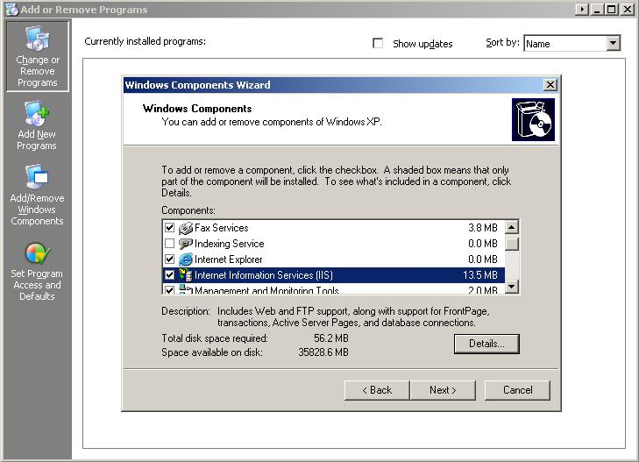

- Click Details…
- Click in the Tick Box next to SMTP Service
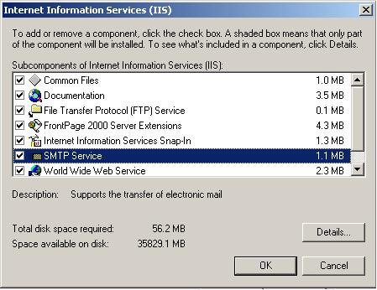

- Click OK twice
- Click Next
- Wait for the install
- Click Finish

Configure SMTP Service
- Click the Start Menu
- Choose Control Panel
- Double Click Administrative Tools
- Double Click Internet Information Services (IIS) Manager
- Expand the [+] Symbol for the Machine
- You should see the Default SMTP Virtual Server.
- Expand the [+] Symbol for the Default SMTP Virtual Server
- Click on Domains
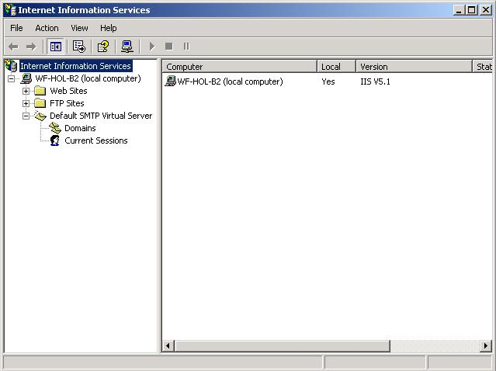

- Note down the Domain Name that appears in the right hand panel.
- Right Click on Default SMTP Virtual Server
- Choose Properties
- Click on the box for Enable logging
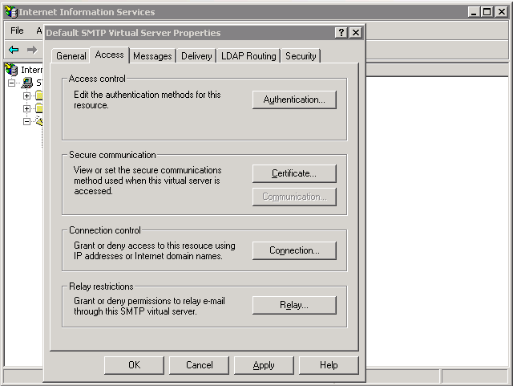

- Click on the Access tab
- Click on Relay…
- In the Relay Restrictions dialog click on Add…
- Enter the IP address 127.0.0.1
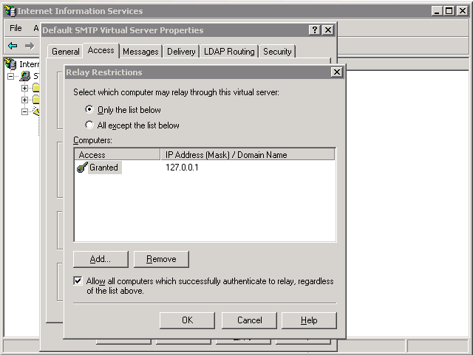

- Click OK three times
- Close the Internet Information Services (IIS) Manager

ASP .NET SQL Server Setup (required for Lab 5 only)
1. Click the start button then choose Run
2. Type \WINDOWS\Microsoft.NET\Framework\v2.0.50727\aspnet_regsql.exe and click run.
3. The following dialogue will appear. Click next.
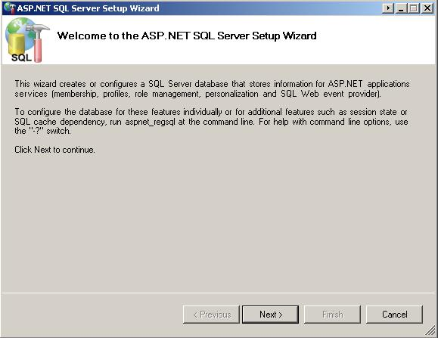

- Choose Configure SQL Server for application services and click next
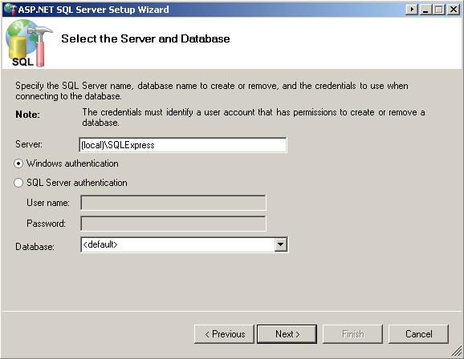

- For the server field enter (local)\SQLExpress then click next.
- Click next then click Finish

Using the Labs

Lab Files Location
The Windows Workflow Foundation Lab files are located in the C:\Windows Workflow Foundation\Labs directory. The hands on lab documents are contained within this directory. The Labs directory also contains a sub-directory for each Lab (i.e. \Labs\Lab01, \Labs\Lab02). Within each lab directory you will find the following sub directories:
- \Completed - This sub directory contains all of the completed exercises. You can open up the completed exercises, review the code, and run it to see what’s required to complete the lab exercise.
- \Resources – This sub directory contains any dependency files, assemblies (.dlls), code snippets, and templates needed for the lab.
For example, the following diagram shows the lab directory structure for Lab01.

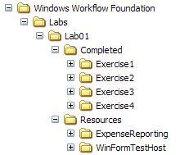

Visual Studio 2005 Code Snippets
The Windows Workflow Foundation labs take advantage of a Visual Studio 2005 feature called code snippets for large blocks of code. Code snippets allow you to easily insert code within a Visual Studio code window. To use a code snippet, simply right click in the code editor and select Insert Snippet from the context menu. Then you can begin using the inline menu to navigate the code snippets.
For example, the following screenshot shows how to navigate and use a code snippet for Lab04:

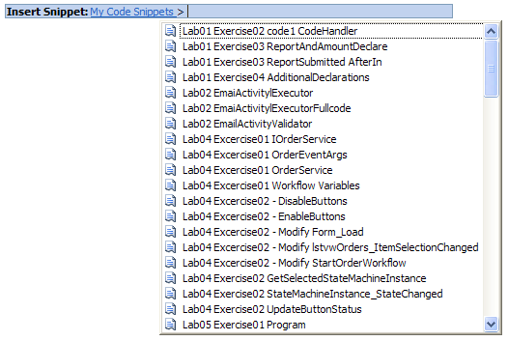

More Information

For more information about Windows Workflow Foundation see the MSDN workflow page.
http://msdn.microsoft.com/workflow

And join in our Windows Workflow Community including a forum site and sample activity downloads.
http://wf.netfx3.com

Change History

June 2006 – Released for the release candidate of Windows Workflow Foundation in C# only.
Nov 2006 – Labs were tested on the released version of .NET Framework 3.0 which includes Windows Workflow Foundation and no updates were required.
April 2007 – They are being re-released now in April 2007 including both C# and VB.NET versions.

